**C2C Data Migration Hands-on**

**Business Case**: Due to business reasons, decision was taken to move the database of the application from AWS to Azure. Here migration is done from AWS RDS to Azure MySQL Server using Azure Database Migration Service.

**Process**: Source server is the AWS RDS instance. Premigration testing is done on the source server. Create a new mysql database in Azure. Target server is this new Azure MySQL database. Database migration project migrates the data from source to target in a single migration. As there is a limitation in Azure Data Migration Service, we need to create Schema, tables, indexes, routines in the target db. DMS will only migrate the data into the existing tables. Application is then connected to the new database and postmigration testing is done.

**Main Tasks**

1. Create DB in Azure.
2. Create Migration Service.
3. Connect the DB and create Schema.
4. Create Migration Project.
5. Test Schema and Data.
6. **Create DB in Azure.**
   1. Log in to Azure portal <https://portal.azure.com/>
   2. Go to Azure Database for MySQL servers.
   3. Click Create.

* + 1. Select Flexible server.
    2. Create New Resource Group. (Please append your name to the all the resource names, if you are using verity azure account)

* + 1. Enter Server Name. (Make sure to use your first name as starting letters).
    2. MySQL Version = 8.0

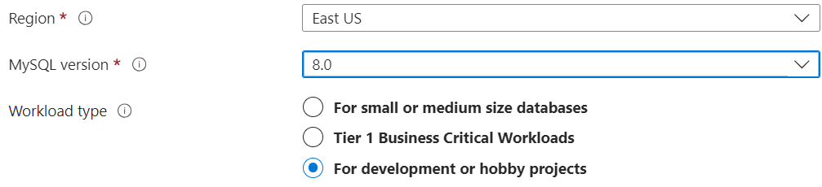

* + 1. Enter Username, password, confirm password.

* + 1. In Networking, select Public access.

* + 1. Check Allow public access from any Azure service within Azure to this server.
    2. Also add access from all Ips (Only for us to connect from laptop Workbench. If you have static IP for your laptop then can enable only that).

* 1. Review and Create.

1. **Create Migration Service**
2. Go to Azure Database Migration Service.
3. Click Create.

* 1. **Select MySQL option**.
  2. Select Resource Group.
  3. Enter service name.

* 1. In the Network tab, enter a name for a new network.

1. Click Create.
2. Wait till resource is created.
3. Update Server parameters
   1. sql_mode
   2. require_secure_transport = OFF

1. **Connect the DB and create Schema.**
2. Open MySQL Workbench.
3. Click next to + sign near MySQL Connections.
   1. Enter Connection name as Azure Source.
   2. Enter Host name, username, and password from Azure DB.
   3. Click Test connection.
   4. Click ok.
   5. Open the connection.
   6. Click on new Schema.

* 1. Enter name college_mgmt and apply.

1. **Create Migration Project.**
2. Go to the service.

1. Enter project name.
   1. **Source: MySQL**
   2. Target: Azure Database for MySQL.
   3. Click Create and run activity.

* 1. Enter Source server.

* 1. Data consistency options = None

* 1. Enter Target server, database, tables (select Migrate Schema).

* 1. Enter Activity name and click Start Migration.

1. Click refresh to check the migration status.
2. Connect again from Workbench.
3. Test the data.
4. **Test Schema and Data.**
5. Connect to the new DB from Workbench.
6. Test the data.